Getting Started Checklist

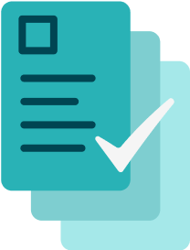
School COVID-19 Testing

Define Your Testing Protocol and Select Your Vendor
- Find the right program for your school district and understand the testing options available (e.g., what type of test, how often, students / staff, vendors)
- Make contact directly with the vendor to ask questions and set target start date
- Connect with your local board of health to agree on a contact tracing protocol

Identify Your Testing Team (See our Guide)
- Identify District Testing Program Manager, School Testing Coordinator, School Outreach Leads, and staff to oversee specimen collection
- Complete trainings from vendor to learn how to administer the test and how to use the software to manage your testing roster and public health reporting
School Communications (See our Communications toolkit)
- Create your Three Phase Communications Plan
- Schedule initial introductory webinars for school staff & community
- Create a webpage to answer FAQs about the program
- Set a goal for participation in the program and make a plan to meet it
- Set up your dashboard and plan for regular communication of test results

Software and Regulatory Set Up
  - If you are using a point of care test that requires it, apply for a CLIA Waiver. Ask your testing vendor and your State Department of Health for details
  - Establish standing physician order. State Departments of Health may establish state-wide standing orders or schools can find a local physician to order
  - Decide whether the testing roster and results will be managed by each school or by the district as a whole
  - Create a process for collecting consents that includes multiple languages and multiple ways to give consent (e.g., verbally, on paper, in a simple online form)
Testing Logistics and Supplies (See our Getting Started toolkit)
- Confirm start date with testing vendor
- Establish and document testing schedule
- Identify testing area(s) at each school and document collection method
- Confirm process for transporting specimens to the lab
- Distribute PPE (surgical and N95 masks, eye protection, gloves, gowns), test kits, and supplies (hand sanitizer, sanitizing wipes, tissues) to each school

