**Take the #TestingPledge   
It’s as easy as 1-2-3!**



**1**



**Quick, painless short nasal swab or saliva sample once a week**

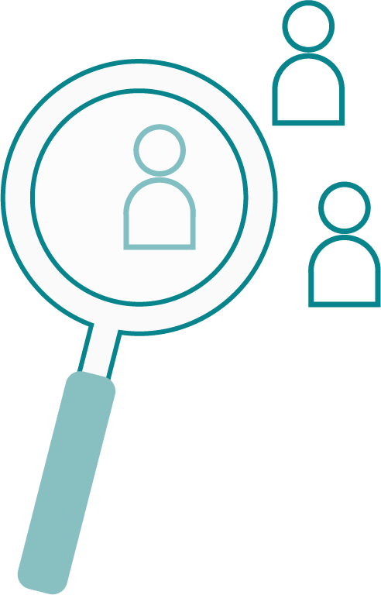

**Identify any positive cases or clear everyone**

**PLACE QR CODE OR LINK HERE**

**All we need from you is a signed permission form.**

**2**

**Continue safely learning at school**

**3**